STEP 5. Time.

The Avalon Water Purifier uses activated Oxygen to destroy pollutants and neutralize odors. Although the Avalon Water Purifier can deliver immediate results, it is important not to expect the Royal Air Purifier to remove strong pollutants or odors immediately. Give the Avalon Water Purifier some time to purify the liquid.

BE PATIENT! Different liquids with different contaminants require varying amounts of concentration and exposure to adequately purify the liquid. Volume, temperature and surface dissipation are variables that affect the outcome and time needed to purify the liquid. Tap water in a 1 gallon container at 38° should be treated for roughly 30-45 minutes.

STEP 6. Storage after usage

Leave the Avalon Water Purifier running for 2 minutes after removal from the liquid to avoid clogging the micro-bubbler. Dry off the bubbler with a paper towel. Wipe clean the silicone hose and store the bubbler and hose in a clean dry bag for later use.

PRINCIPALS OF OPERATION

Royal Air Purifier unleashes the power of a thunderstorm to purify the air, making your environment cleaner and healthier. The patented Aran generator creates a special electrical corona that energizes oxygen in the air similar to the effect of the discharge of a lightning bolt. The Royal Air Purifier simply accelerates the process Nature uses to break down air pollutants, leaving the air smelling fresh and clean without using chemical fragrances or costly filters.

Since the Royal Air Purifier uses Oxygen, it is the natural and safe way to achieve fresher indoor air.

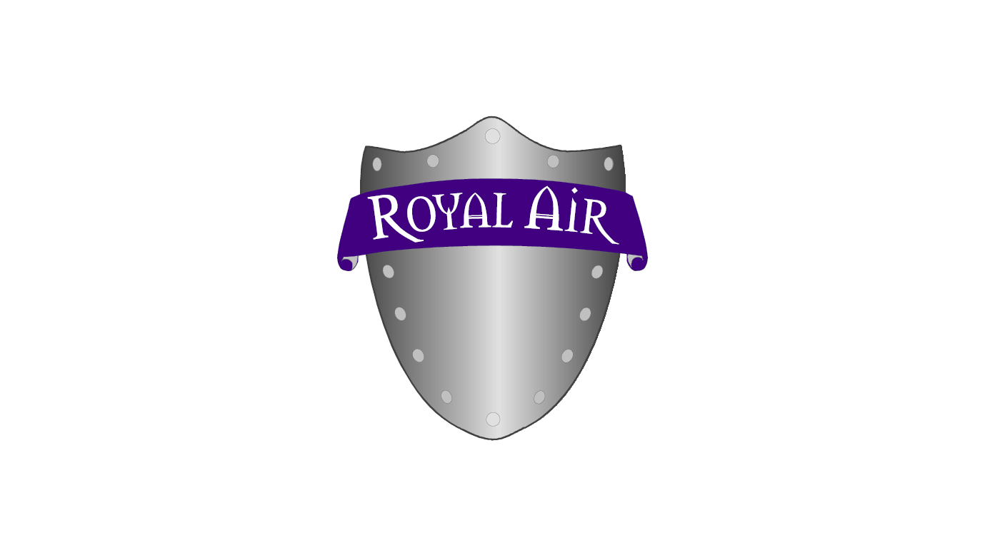
DISCLAIMER:
The Company makes no therapeutic claims as to the use of this equipment. Use of the equipment by the purchaser is entirely left to the discretion of the purchaser and under no circumstances does the Company make any representations other than those contained herein.

ROYAL AIR LLC (330) 775-3014 or (216) 759-6422
P.O. BOX 40
CHIPPEWA LAKE, OH 44215

p. 3

- The Dry Heat Sauna/Steam Heat Sauna application: by removing the Bubbler from the hose, you can insert the silicone tub into your sauna and allow the surface of your skin to be exposed to the ARAN air while you are still enclosed in your sauna.

- The Body De-odorizer application: Using a large plastic leaf bag (bag used in the Fall to bag dried leaves), you can sit inside the bag pulling the opening up around your neck. Placing the hose either down the opening around your neck or through a small hole in the bag, you can de-odorize your body and clothes while sitting in the bag. The amount of time needed to complete this task is directly proportionate to the amount of body odor that you may have or the amount of pollution saturated in the clothing.

- De-odorizing Clothing/other objects Application: Using a large Leaf bag (same bag as in #7), you can place clothing, blankets, pillows, sheets, towels, pet beds, shoes, socks, etc. into the bag and insert the hose through the opening or through a tiny hole that you make in the bag. A few small holes should be made in the bag to allow the ARAN air to escape and not create any “back pressure” in the pump of the AVALON 1 unit. The amount of time needed to complete this job is directly proportionate to the amount of pollution that is saturated within the objects being purified.

- Walk-in Coolers for Meats and/or Produce: By drilling a ¼” hole into a walk-in Cooler, you can insert the hose of the AVALON 1 unit into the Cooler and begin processing the contents with ARAN Air. The AVALON 1 unit can remain outside in the work area without being placed into the Cooler. The amount of time needed to complete the process is directly proportionate to the amount of Meat/Produce that is in the Cooler. The unit can be placed on the permanent “on” position of the Timer and allowed to run as long as it is necessary to achieve the desired results.

- Deli-Case application: By drilling a ¼” hole into a Deli Case, you can pump ARAN air into the Deli Case without placing the unit into the case. It will keep the food (lox, potato salad, cheese cake, deli meats etc.) from cross flavoring and free of harmful bacteria which cause food to spoil and people from getting contaminated food. It will extend the shelf life of the food.

- Fruit and Vegetable Processing Application: By placing the Bubbler in a large bowel of Water, you can place fruits and/or vegetables around it and begin oxidizing harmful pesticides and fungicides that may still have a residual amount remaining on the food. This cleansing action will help remove these harmful materials and increase the food value of the fruits and vegetables if they are not on the food when you eat it. It will destroy mold, fungi and bacteria that may be on the surface of the food.

- Diaper Bag de-odorizer: By placing the hose without the Bubbler into a diaper bag, it will help kill bacteria and eliminate odors associated with the task of cleaning dirty diapers. This can be done before AND after the diapers are washed.

p. 8

