QUESTIONS AND ANSWERS ABOUT THE ROYAL AIR PURIFIER

Q: Can I leave the Avalon Water Purifier on 24 hours a day?

A: Yes, the Avalon Water Purifier is designed to operate continuously. The Avalon Water Purifier uses less electricity than a 40-watt light bulb, so it will not run up your electric bill.

Q: What is the slight hissing or buzzing sound I hear coming from the Royal Air Purifier? Is this normal?

A: This is normal. It is the sound of the energy corona inside the Aran generator, which energizes the Oxygen in the air.

Q: What is the vibrating sound I hear coming from the Avalon Water Purifier? Is this normal?

A: This is normal. It is the sound of the pump creating pressure to push the Activated oxygen through the hose and into the liquids.

Q: Is the Activated Oxygen safe for children and pets?

A: Yes, Oxygen is Nature’s purifier. It is safe and effective.

If you have any questions or concerns that were not answered, feel free to contact us at:
ROYAL AIR LLC
P.O. BOX 40
CHIPPEWA LAKE, OH 44215
Tel: 330-775-3104
Tel: 216-759-6422

p. 5
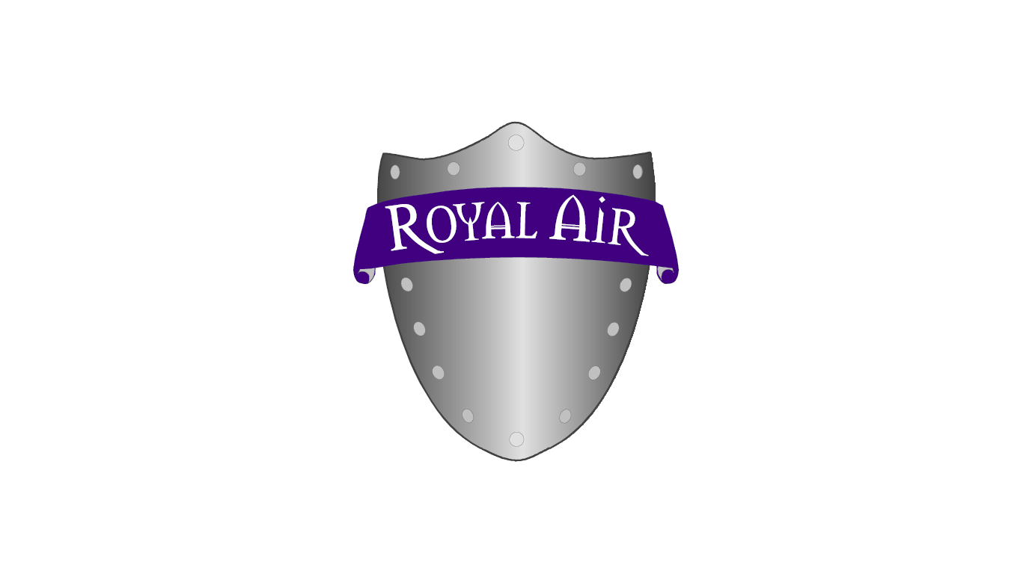

DISCLAIMER

CAUTION: The Royal Air Purifier may cause unprotected metals that are close to the unit to tarnish. We recommend a coat of spray Urethane varnish on bare metal surfaces to protect them. Aran may also cause natural rubber to degrade so keep your rubber bands in a sealable bag to protect them.

p. 6

