QUESTIONS AND ANSWERS ABOUT THE ROYAL AIR PURIFIER

Q: It says in the Instruction Book to place the Royal Air Purifier in a high location – Will the Royal Air Purifier still work if its not placed up so high?

A: Yes, the Royal Air Purifier will still work but it will work more effectively if placed higher. Many pollutants rise upward in a room such as cigarette smoke. The higher up in the room the Royal Air Purifier is placed the more effectively it can work on these pollutants. For optimal effectiveness try to place your Royal Air Purifier at least 6’ from the ground.

Q: Can I leave the Royal Air Purifier on 24 hours a day?

A: Yes, the Royal Air Purifier is designed to operate continuously. The Royal Air Purifier uses less electricity than a 40-watt light bulb, so it will not run up your electric bill.

Q: What is the slight hissing or buzzing sound I hear coming from the Royal Air Purifier? Is this normal?

A: This is normal. It is the sound of the energy corona inside the Aran generator, which energizes the Oxygen in the air.

Q: Is the Activated Oxygen safe for children and pets?

A: Yes, Oxygen is Nature’s purifier. It is safe and effective.

If you have any questions or concerns that were not answered, feel free to contact us at:
ROYAL AIR LLC
P.O. BOX 40
CHIPPEWA LAKE, OH 44215
Tel: 330-775-3104
7.

USING YOUR NEW AIR PURIFIER STEP-BY-STEP

STEP 1. Remove the Royal Air Purifier from the packaging:

If after removing the Royal Air Purifier from the shipping carton it appears to have any physical damage that occurred during the delivery, contact the dealer or distributor you bought the Royal Air Purifier from for information on returning the unit. Do not plug it in! Keep all packaging materials for damaged shipping claims or return shipment for repair.

STEP 2. Placing your Royal Air Purifier

Your new Royal Air Purifier works best if placed in a high location. On top a bookshelf, refrigerator, or cabinet is an excellent place. The higher the better – this gives the “Super Oxygen” space to cascade down through the room as it cleans and refreshes the air.

Place the Royal Air Purifier in the room where you desire it to have the strongest effect.

Good ventilation or airflow is important. If you want the Royal Air Purifier to purify a large area or several rooms in your home – leave door in your home open or slightly ajar to allow the “Super Oxygen” a means to disperse. Opening a window slightly to allow fresh Oxygen into the room is sometimes helpful and will not diminish the cleaning power of the Royal Air Purifier.

STEP 3. Setting the Royal Air Purifier Output:

Start the Royal Air Purifier on its lowest setting. The low setting is the point where the unit clicks on from the off position.

STEP 4. Plugging in the Royal Air Purifier

Unwrap the power cord and plug it into a near-by electrical outlet. The Royal Air Purifier will make a slight hissing sound while operating – this is normal. This sound will be more noticeable when the Royal Air Purifier is on “Higher settings”.
4.
CAUTION: CONNECT ONLY TO ALTERNATING CURRENT (AC): 110 VAC 60 Hz. NEVER CONNECT TO DIRECT CURRENT (DC)!
STEP 5. Breathe fresh air.

QUESTIONS&
ANSWERS

The Royal Air Purifier uses activated Oxygen to destroy pollutants and neutralize odors. Although the Royal Air Purifier can deliver immediate results, it is important not to expect the Royal Air Purifier to remove strong pollutants or odors immediately. Give the Royal Air Purifier some time to purify your indoor environment.

BE PATIENT! Allow the Royal Air Purifier time to oxidize pollutants and odors.

STEP 6. Using the Royal Air Purifier

After first starting the Royal Air Purifier on its lowest setting you can adjust Royal Air Purifier’s output to a higher setting in order to clear strong pollution and stubborn odors like: cigarette smoke, pet odors, cooking smells etc. Once the air is fresh and clean again, you can the Royal Air Purifier back to a lower setting.

When the Royal Air Purifier is set properly you should sense a slight freshness to the air, similar to the freshness experienced after a thundershower.
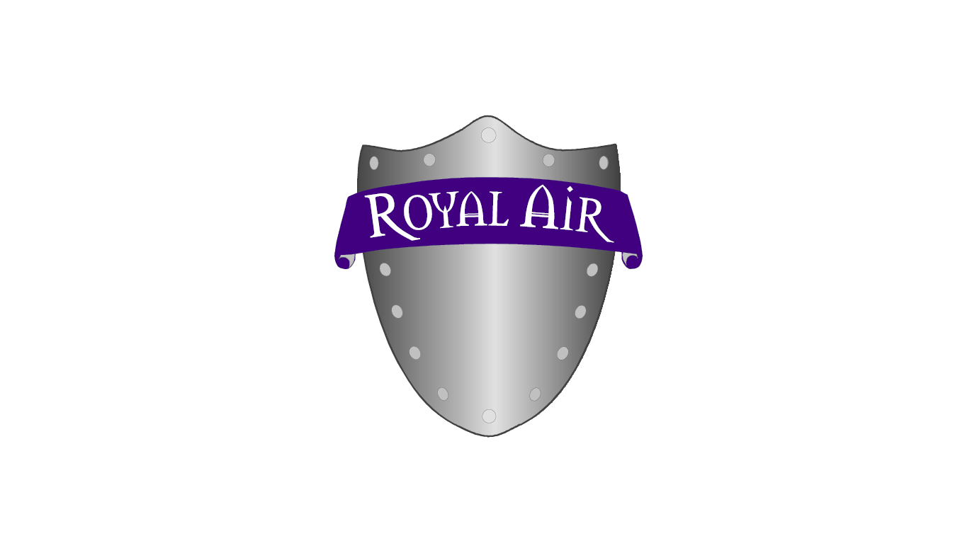

PRINCIPALS OF OPERATION

Royal Air Purifier unleashes the power of a thunderstorm to purify the air, making your environment cleaner and healthier. The patented Aran generator creates a special electrical corona that energizes oxygen in the air similar to the effect of the discharge of a lightening bolt. The Royal Air Purifier simply accelerates the process Nature uses to break down air pollutants, leaving the air smelling fresh and clean without using chemical fragrances or costly filters.

5.
Since the Royal Air Purifier uses Oxygen, it is the natural and safe way to achieve fresher indoor air.

ABOUT THE ROYAL AIR PURIFIER

Q: I sometimes notice a slight sharpness or Chlorine like smell while running the Royal Air Purifier. Could you tell me what this is?

A: This is either the activated Oxygen or pollutants being oxidized by the Royal Air Purifier. If this odor seems too strong try the following:

- If your Royal Air Purifier. Is not on its lowest setting, try turning it down.

- If your Royal Air Purifier is already at it lowest level, try turning it “off” for a while – if this helps, you can purchase from your Royal Air Distributor/Dealer a 24-hour timer to turn the unit “on” and “off” when desired. A fully adjustable control unit is also available which can control the output of up to two Royal Air Purifiers.

Sometimes pollution that you have grown accustom to over time will be noticed while it is being oxidized. BE PATIENT! Allow the Royal Air Purifier time to oxidize pollutants and odors, and give yourself time to adjust to a purified environment.

6.

